

SUMMER EXAMINATIONS 2014

Wednesday, 14th May 2014, 14.30 p.m. – 16.30 p.m.
KSDEM_8_Y2

Courses: Bachelor of Science (Hons) in Software Development

Year: Two

Subject: Software Development

Time Allowed: 2 Hours

Instructions: 1. Attempt any THREE (3) of the following FIVE (5)
questions.

- Questions do not carry equal marks

- Start each question on a new page.

- Write the question number at the top of each page.

- Circle the numbers of the questions you answer at the front of your answer book.

Additional Attachments or Exam Material to accompany this paper:

A. None

Internal Examiner(s) External Examiner(s)
Mr. Brendan Watson Mr Brian Gillespie

Question 1
Read the following information and answer the questions below:

A health insurance company provides health insurance policies to its members. The members may see consultant doctors who may book medical operations for them in hospitals. The consultant doctors and the hospitals are then paid by the health insurance company. The details stored on the insurance company are name, address and registered number and the details stored on health insurance policies are name, renewal premium and total amount paid out. The details stored on members are name, address and the details stored on consultant doctors are name, address and fee amount and the details stored on medical operations are name and cost. The details stored on hospitals are name and speciality.

- Draw the UML class diagram which models the information given above and specify name and multiplicity of each association and specify suitable types for all the attributes. Add roles to each end of any three of the associations in your class diagram. Explain how an association models the potential for links to occur. (14 marks)

- Explain encapsulation. On your UML class diagram specify that all the attributes of the hospital class are private. Provide suitable assessor methods for all the attributes of the hospital class (get and set methods) and specify the signature of each of the assessor methods you added.
(8 marks)

- Add a suitable class scoped attribute to any of the classes in your class diagram and outline why you think the attribute you added should be class scoped.
(4 marks)

- Draw an instance diagram (using the UML notation and your own sample data) for the class diagram you developed and clearly label all parts of the diagram. Your instance diagram should include at least one instance of each of the classes.
(8 marks)

(Total 34 Marks)

Question 2
- Explain what a use case is and what an actor is. (6 marks)

- Document the following use case which you participate in.
- Buy cold drink from vending machine.

Document your use case using the following headings: Use Case Name, Participating Actor, Entry Conditions, Flow of Events, and Exit Conditions. Draw the use case diagram showing the above use case and show the system boundary.
(10 marks)

- Explain what include relationships model. Add another use case to your use case diagram called Buy bag of Crisps. Do you think any of the steps in the flow of events for use case Buy bag of Crisps would be similar to Buy cold drink? If so update the use case diagram to have suitable include relationships and document the included use case using the following headings: Use Case Name, Participating Actor, Entry Conditions, Flow of Events, and Exit Conditions.
(12 marks)

- Document a realistic scenario for the use case you developed in answering question 2b) using the following headings: Scenario name, Participating actor instance, Entry conditions, Flow of events and Exit conditions.
(5 marks)

(Total 33 Marks)

Question 3
- Inheritance allows new classes to be derived from existing ones. Explain two benefits of inheritance. (10 marks)

- Sketch Figure 1 in your answer book and do the following:
(12 marks)

- Label the base class and all of the superclasses and leaf classes.
- Add a subclass called Manager. Objects of this class are employees but in addition managers have an attribute called salary of type integer and a method +paySalary with signature of one argument named amount which is of type integer and paySalary returns a Boolean value.
- Add a suitable association so that Managers must supervise ProductionStaff.
- Add methods hire( ) and fire( ) to the Employee class and override these methods in the appropriate leaf classes.

- List all the features of the Manger and Customer classes. Does the UML diagram that you produced in answering Question 3b) allow Managers to access information on orders. Explain your answer.
. (11 marks)

(Total 33 Marks)
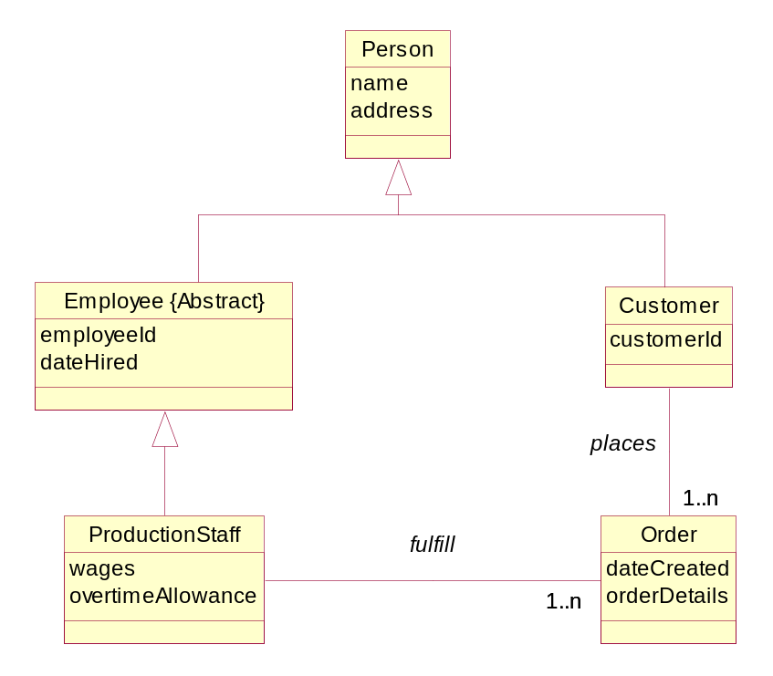
Figure 1

Question 4
- What is the goal of software testing? Explain the difference between testing and debugging.
(6 marks)

- Develop a control flowgraph for the pseudo code sample below and determine the complexity. How many paths would you need to test to guarantee complete coverage? Suppose the bigSquare method below has been tested so that C0 = 85% and C1 = 50%, would you recommend further testing? Explain your answer.
(12 marks)

- Develop a branch and block table for the Pseudo code sample below.
(15 marks)
(Total 33 Marks)

// Below is Psuedo code for bigSquare method.

bigSquare (aGrid : Grid, lengthOfSide : integer): integer //Line Reference Nos.
{ // 1
initialise( ) // 2
4 timesRepeat // 3
{ // 4
lengthOfSide timesRepeat // 5
{ // 6
If ( aGrid PieInSight(this) = true) // 7
{ // 8
eatPie(aGrid) // 9
} // 10
Else // 11
{ // 12
walk (MyGrid) // 13
} // 14
} // 15
2 timesRepeat // 16
{ // 17
turn (right) // 18
} // 19
} // 20
return pieCount } // 21

Pseudo Code Sample

Question 5
- Explain what a model is and why we build models. Explain four aims we achieve through modelling.
(12 marks)
- Draw a diagram of the waterfall lifecycle model and explain any three of its phases. Explain why it is not popular anymore with many organisations moving to more agile approaches.
(13 marks)
- What is a prototype? Explain how development of prototypes reduces risk. (8 marks)
(Total 33 Marks)

